OO Programming Fundamentals

Practical Week 2 – 22nd September 2014

Create a Practical Week 2 folder in your Java folder on your G drive

G:\Java\Practical Week 2

- Save all the following exercises into the Practical 2 folder

Exercise 1
Write a program that will evaluate the following: 2.2 + 3 / 3.1 and print the answer.

Create project in Practical Week 2 folder as: ex2a
Sample Output:

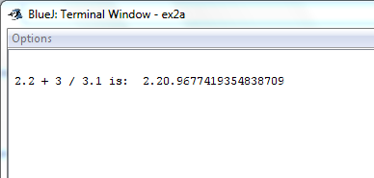

Exercise 2
Write the Greetings program from Moodle Notes (Input into Java Program) – Asking the user to enter their name and printing a greeting to the screen.

Create project in Practical Week 2 folder as: ex2b
Sample Output
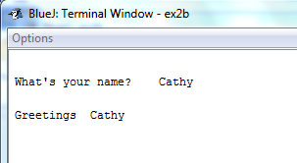

Exercise 3
Write a program to read any integer value from the user (keyboard), store it in a variable, calculate and output its square to the screen.

Create project in Practical Week 2 folder as: ex2c
Sample Output:
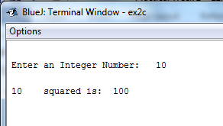

Exercise 4
Write a program that asks the user to enter the length and width of any rectangle and calculate and display its area.

Create project in Practical Week 2 folder as: ex2d
Sample Output
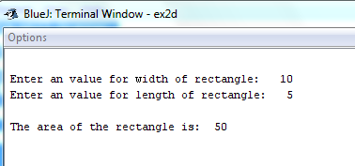

Exercise 5
Write a program to read any two decimal values from the user (keyboard), store the two values in two variables, calculate and output their average to the screen.

Create project in Practical Week 2 folder as: ex2e
Sample Output:
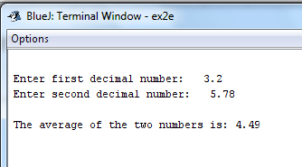

Exercise 6
Write a program that calculates an employee’s gross pay. Input to the program from the user (keyboard) is the hourly rate (i.e. how much they get paid per hour) and the number of hours worked per week. Calculate the gross pay and print the answer to the screen.

Create project in Practical Week 2 folder as: ex2f
Sample Output:
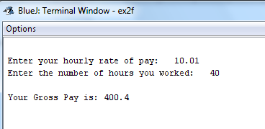

Exercise 7
Write a program to read values for the length, width and height of a rectangular box from the user (keyboard). The programs should calculate and print its volume to the screen.

Create project in Practical Week 2 folder as: ex2g
Sample Output:
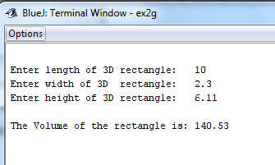

Completing this weeks’ Practical:
- When you submit work, you will send it in zip file format.
- To create a zip file of your practical work:
  - In Windows Explorer, right click on the Practical Week 2 folder that contains your work.
  - When the context menu appears, choose the Send to option, followed by the Compressed (zipped) folder.
  - This will create a new file called Practical Week 2.zip in your current folder
- Note: If you are using your own laptop, you can choose to install very good (and free) compression software called 7zip. Just search for it in Google and download it.

*** It is this zipped file that you will upload into Moodle.***

